

**NAME: INDEX NUMBER: EMIS NUMBER: DISTRICT NAME:**

**SST AND R.E SECTION A**

1. Write another name for the prime meridian.
2. Mention any one important source of clean water in your community.
3. State any one benefit that a school may get from its neighbourhood or nearby community.
4. Identify any one dishonest behaviour that may be shown by a school during a sports competition.
5. Give any one example where a person in our community has been shown gender bias.
6. Why is it so important for all families in Uganda to own a radio?
7. Name the branches found on the United Nations flag.
8. How did long distance trade aid the development of Mirombo’s kingdom?
9. Why did the Nilotics change from nomadic pastoralism to mixed farming?
10. Give a reason why people should grow a lot of non-traditional cash crops.
11. How does thick vegetation modify climate of nearby places?
12. Name the district leader who heads all hospitals in a district.
13. Write any one way in which the mining of petroleum oil will improve the transport sector in Uganda.
14. Give one way colonial masters delayed African countries to get independence.
15. Why is it important for someone to compare prices at different stalls before spending money?
16. Write one way the Judiciary can promote law and order in a country.
17. Give any one effect of brick making to our environment.
18. Write one way in which missionary work led to colonization in Africa.
19. Write any one social value of goats to the people in your community.
20. What is a map?
21. Name the first political party to be formed in Uganda.
22. State any one reason why class monitors are important.
23. Why is coffee called a plantation crop?
24. Give one role of children in promoting security at home.
25. Why were there regents in Buganda kingdom by the time of signing the 1900 Buganda agreement?
26. State any one reason why PIASCY messages are taught in schools.
27. Mention the political reason given for creating many districts in Uganda.
28. State the difference in formation between L. Tanganyika and L. Victoria.
29. Write ECOWAS in full.

# Study the sketch map of Africa below and use it to answer question 30

1. 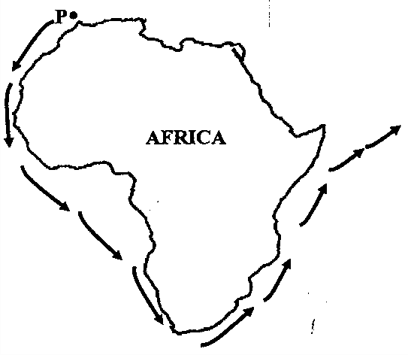Name the city marked P from which the explorers that used the shown route came from.
2. Why do some trees in desert areas have thin leaves?
3. Give one reason why children’s rights should be observed.
4. Give the factor that made the Plain Nilotes fail to form kingdoms.
5. Which discovery marked the end of the Stone Age period?
6. Mention any one way in which rubbish can be managed in a school environment.

# In questions 36 – 40, answer Either Christianity or Islam but not alternatives in a number

1. **Either**: Name any one type of prayer that brings Christians together.

**Or**: Name any one type of prayer that brings Moslems together.

1. **Either**: Write one problem that early Christian converts faced.

**Or**: Write one challenge that early Muslim converts faced.

1. **Either**: Why do Christians celebrate Easter day?

**Or:** Why do Moslems celebrate Iddi- Adhuha?

1. **Either**: Name the book in the Bible that talks about creation.

**Or**: Name the Surat that talks about creation in the Quran.

1. **Either**: Write one way in which a Christian can strengthen faith in God.

**Or**: Write one way in which a Moslem can strengthen faith in Allah.

# SECTION B ( 60 MARKS)

1. 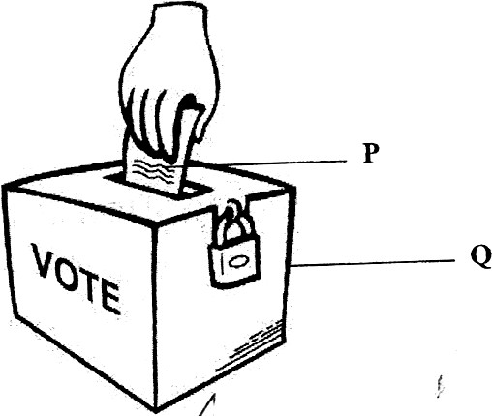The diagram below shows a polling station and some of the things used there.
   1. Name the items marked P and Q
      1. P
      2. Q _
   2. Identify any two different people responsible for managing a polling station during elections.
      1. ii)
2. a) What title is given to the highest civil servant in a ministry?
3. Why is it important for people who work in the private sector to pay NSSF?
4. Outline two ways in which leaders can improve the welfare of people in their community.

i)

1. a) Name the official from Britain who extended IBEACo activities to Uganda.

b) Write two things that made the IBEACo. to run bankrupt. i)

ii)

c) Which crop is very popular on the Gezira Irrigation scheme?

1. a) How did Sir. William Mackinnon contribute to the fight of slavery in Uganda?
2. State any two factors which favoured the estasblishment of the Gezira irrigation scheme.

i)

ii)

1. Name the Portuguese explorer who invented a compass.
2. a) State any one problem farmers on the Gezira irrigation scheme face.
3. State the use of a compass.
4. Give one reason why the Portuguese explorers wanted to discover a sea route to India.
5. State any one reason why the Portuguese were interested in the Coast of

E. Africa.

1. a) Which National exercise enables government to know the number of people living in a country?
2. State any two ways in which a low population can negatively affect the economic development of a country.
   1. ii)
3. Why does the Uganda government encourage people to practice family planning?
4. a) Give one importance of each of these places in our community
5. Hospital
6. Post office
7. Radio station
8. Bank
9. a) What policy was practiced in South Africa which separated blacks from whites?
10. Name the first black president of South Africa who fought against the named police above.
11. State one way the policy mentioned above negatively affected the black people in South Africa.
12. Give one way the above policy was brought to an end in South Africa.
13. a) Apart from using pipelines, mention any other means of transporting petroleum products in E. Africa.
14. Mention two disadvantages of using pipes in transporting petroleum products.
15. State one benefit of using pipes in transporting petroleum products.
16. Insecurity means the state of being open to danger or threat. i.e lack of protection
    1. State any three effects of insecurity.

       2. iii)
    2. What is the difference between child work and child labour?

# For questions 51 – 54, answer Christianity or Islam not both on each

1. **Either**: a) Who committed the first murder according to the Bible?
2. What immediate punishment did God give to the person in (a) above?
3. Give any two ways murder is a sin.

i) ii) **Or**: a) According to the Quran who committed the first murder?

1. What immediate punishment did Allah give to the person in (a) above?
2. Give any two ways murder is a sin.
   1. ii)
3. **Either**: a) On which day did the Holy Spirit descend onto the apostles?
4. What happened after the apostles had received the Holy Spirit?
5. State any two ways the Holy spirit guides us today as Christians.

i) ii)

**Or**: a) On which night did Prophet Muhammad receive the first revelation?

* 1. Name the month during which the Holy Quran was revealed to Prophet Mohammad.
  2. How was the Holy Quran revealed to Prophet Mohammad?
  3. State any one way the Quran is a holy book of Allah.

1. **Either**: a) Name the two parts of the Bible.
2. ii)
3. Which part of the Bible talks about the story of creation?
4. Give any one way one can use a Bible to meet daily needs.

**Or**: a) Name any two Islamic holy books apart from the Quran.

# i)

2. Name the last book of the Islamic Quran.
3. Give any one way one can use a Quran to meet daily needs
4. **Either**: a) What term is used to mean the existence of one God in three persons?
5. Who is God the son according to the Bible?
6. Give any two ways God the son is important to Christians today.

i) ii)

**Or**: a) Why are Muslim females advised to wear long dresses (Sharia) during prayer?

b) Give any two situations where males and females are not allowed to mix freely.

i)

ii)

c) State any one way Allah is important to Moslems today.

1. **For Both**: a) In which two ways has Christianity and Islam promoted development in Uganda?

i)

ii)

b) State any two challenges the above religions have faced as they try to promote development in Uganda.

i) ii)

# END